

ECE 528/L

Robotics and Embedded Systems with Lab

Final Project Proposal

Suren Bursalyan
Aramayis Sargsyan
Instructor: Aaron Nanas
Fall 2025

Objective:
The main objective of the project is to create a heat-seeking robot. We will implement a infrared sensor and an Arduino uno onto a chassis and program the hardware so that this vehicle will move to the hottest object in its vicinity.

Background and Methodology:
The embedded systems and robotics concepts that will be applied in the project include, but are not limited to motor control using PWM, GPIO, sensor fusion, and decision-making algorithms.
The overall plan to accomplish our project’s objectives is to acquire a thermal/infrared sensor, get the Arduino mounted on a chassis, and figure out how to interface the sensor with an Arduino using I2C communication protocol. Furthermore, some algorithms that will definitely be implemented are the PWM and motor control algorithms, possibly timers etc. Additional algorithms are needed to implement required logic for how the vehicle will approach the hot object and how it will detect the hot object.
- Some hardware components include: an infrared sensor, Arduino uno r3, and a breadboard.
- Some software components include: Arduino IDE
Block Diagram:
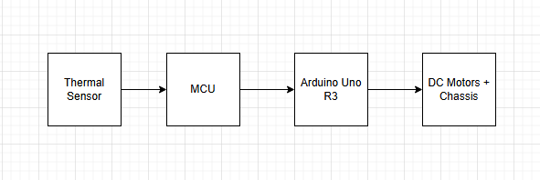

Pinout Plan:
- TBD

Components Used:
So far we expect to use the Arduino uno R3 and its MCU, a robot chassis similar to the ti rslk chassis, and a thermal/infrared sensor.

Group Members:
- Suren Bursalyan
- Aramayis Sargsyan

